CUSTOMS DUTY
Meaning:
Customs duty refers to the tax imposed on goods when they are transported across international borders. In simple terms, it is the tax that is levied on import and export of goods. The government uses this duty to raise its revenues, safeguard domestic industries, and regulate movement of goods.
- Union List: The levy of Import and Export duty is derived from Entry 83 to List I (Union List) of 7th Schedule.
- Levy: Duties of customs shall be levied on all imported and exported goods. It applies to both, goods belonging to the government and not belonging to the government.
- Rate: Duties are levied at rates specified in the Customs Tariff Act, 1975 or any other law for the time being in force.
Different types of Customs Duties:
The following duties are leviable by the Customs Department as per the Customs Tariff Act, 1975
Duties

Import duty
Export duty

CUSTOMS DUTY
a)Import Duties – Basic Customs Duty, Additional Customs duty, Special Additional duty of Customs, Protective Duties, Safeguard duty, Countervailing duty on subsidized articles, Anti Dumping duty.
b)Export Duties – Standard rate of duty, Preferential rate of duty.

Types of custom duty:

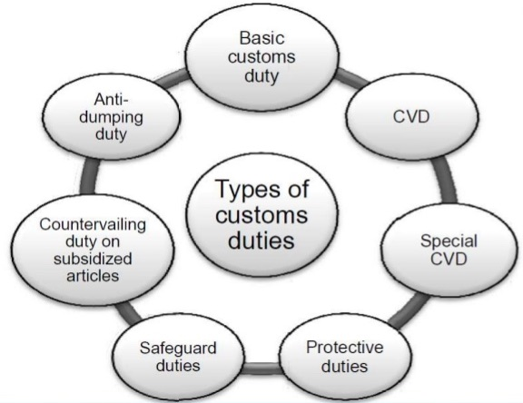

CUSTOMS DUTY

1) Basic Customs Duty:
The Basic Customs Duty is levied under Sec. 12 of the Customs Act, 1962. As per Sec. 2 of the Customs Tariff Act, 1975 preferential rate of duty is always lesser than standard rate of duty. The importer has to satisfy certain conditions to avail the preferential rate of duty on imported goods.
2) Additional Duty of Customs or Countervailing Duty (CVD):
As per Sec. 3(1) of the Customs Tariff Act, 1975 any article which is imported into India is subject to duty (in addition to BCD) equal to the excise duty for the time being leviable on a like article if produced or manufactured in India.
The duty can be levied only if the article is such that it could be manufactured or produced in India. If the article is not produced or manufactured in India, the excise duty that would be leviable on those goods had it been manufactured in India is the base.
However, if goods manufactured in India is exempt from excise duty then there is no additional duty of customs.
3) Special Additional Customs Duty:
The imported goods shall in addition to basic customs duty and additional duty shall also be liable to special additional duty, which shall be levied at a rate to be specified by Central Government. Such rate shall be notified by the Central Government having regard to the maximum sales tax, local tax or any other charge. At present, the special CVD rate is 4%.
4) Protective Duties:
Protective duties are levied by the Central Government upon the recommendations made by the Tariff Committee and upon it being satisfied that circumstances exist which render it necessary to take immediate action to provide protection to any industry established in India. While calculating protective duties, we should not calculate the education cess and secondary and higher education cess. As per WTO, protective duty is not supposed to be levied. Hence at present this duty is not in force.
5) Safeguard duty:
CUSTOMS DUTY

It is imposed for the purpose of protecting the interest of any domestic industry in India. It is product specific. While calculating protective duties we should not calculate the education cess and SHE cess. The Central Government of India can impose provisional safeguard duty pending final determination upto 200 days.
6) Countervailing duty of subsidized articles:
Duty levied if the articles are imported into India by getting the subsidies from other country. While calculating protective duties, we should not calculate the EC and SHEC.
7) Anti Dumping duty:
This duty is country specific. It is imposed on importers of a particular country. Dumping exists when a product is exported from 1 country to another country at an export price is less than its normal value prevailing in the exporting country. The difference between the normal value and the export price is the dumping margin based on which the anti dumping duty is imposed. While calculating protective duties we should not collect the EC and SHEC.
Abatement of duty on damaged or deteriorated goods:
1) Circumstances:
Damage or Deterioration (all Imported goods) | Damage to Imported goods (other than warehoused goods) | Damage to warehoused goods
Imported goods had been damaged or deteriorated at any time before or during the unloading of the goods in India. | Imported goods had been damaged on account of any accident at any time after unloading in India, but before their examination u/s 17 | Warehoused goods damaged at any time on account of any accident, before clearance for home consumption.

CUSTOMS DUTY

Note: Accident should not be due to any (a) willful act (b) negligence (c) default of the importer, his employee or agent.
2) Abatement:
The duty will be reduced proportionately to the reduction in value, if it is shown to the satisfaction of AC or DC that the damage or deterioration had taken place in the above manner.
3) Valuation:
The owner of the goods has the option to choose from any one of the following methods for the valuation of damaged goods –
- Value of goods may be ascertained by the proper officer, or
- Damaged goods may be sold by the proper officer by (i) public auction or (ii) by tender or (iii) in any other manner with the consent of the owner. The gross sale proceeds shall be deemed to be the value of such goods.

Remission on duty on lost, destroyed or abandoned goods – Sec. 23
1. Physical availability:
- Lost / destroyed goods are not physically available.
- Abandoned goods are physically available.
2. Quantity Lost:
- Any quantity
3. Duty liability
- Duty is leviable. But AC / DC may grant remission for lost / destroyed goods.
- Owner not liable to pay duty for abandoned goods.
4. Nature of Benefit:
- Benefit is given by Statute, but discretion is available to AC /DC.
5. Burden of proof:
CUSTOMS DUTY

- Loss / destruction due to natural causes, should be proved by importer.
6. Restoration:
- Restoration is not possible, since goods are physically lost / destroyed.
7. Abandonment:
- Sec. 23 covers situations of abandonment / surrender also.
8. Time point:
- Lost / destroyed any time before clearance for home consumption (either directly or from warehouse)
9. Warehoused goods:
- Applicable to warehoused goods also.

Customs Duty Drawback
The term ‘duty drawback’ means drawing back of the duties paid. As per Sec. 75 of the Customs Act, 1962, drawback is given as an amount to the exporter which represents:
- The duty paid on imported inputs which are used in the manufacture of export goods.
- The excise duty paid on the indigeneously produced inputs used in the manufacture of export goods.
- The service tax paid on input services.
- However, the amount of drawback paid would not exactly relate to the actual import duty and excise duty components. It is determined by the government on the basis of an average amount of duty having regard to all the circumstances and facts of the manufacturing industry.

